# Running the app:

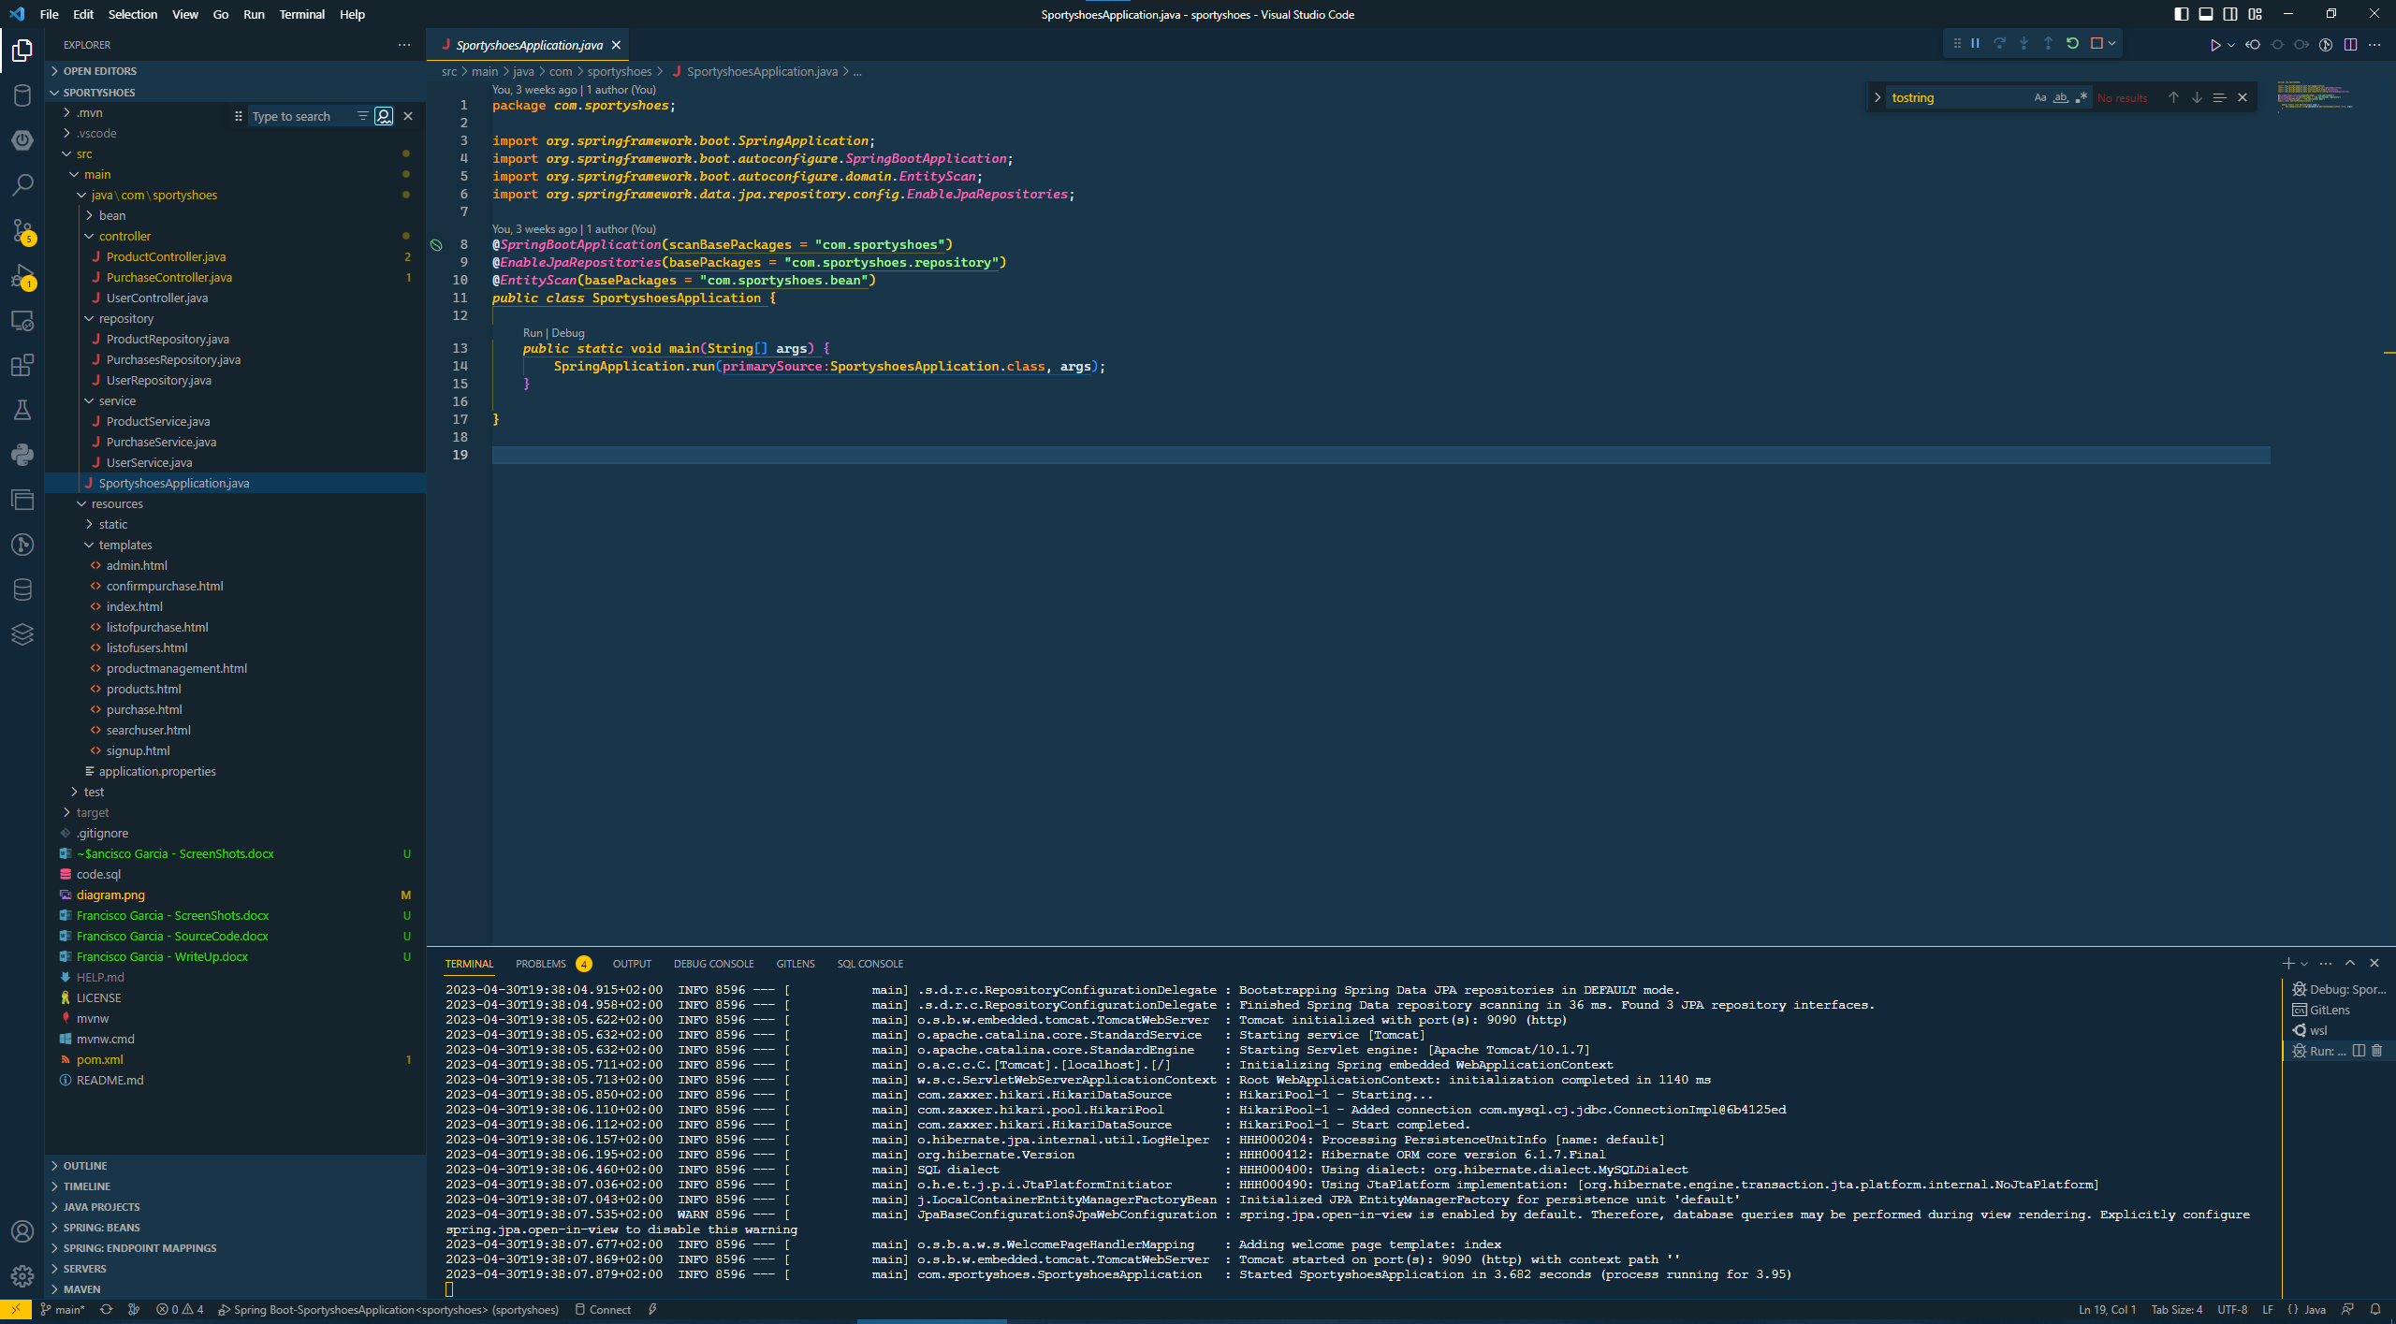

# Main page:

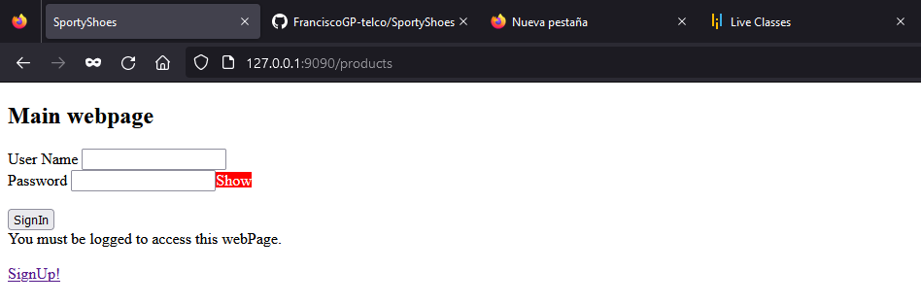

# Sign up form:

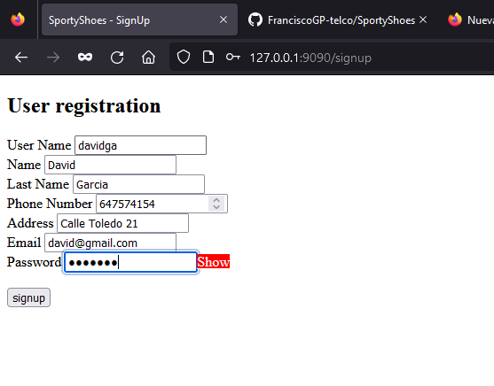

# Checking the user in the DB:

# User logged and main webpage with the list of the products:

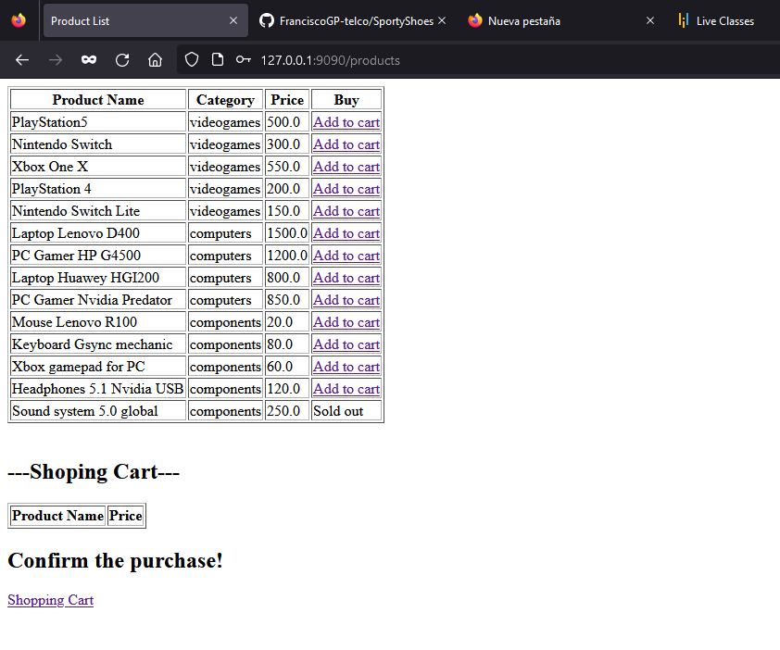

# Adding some products to the shopping cart:

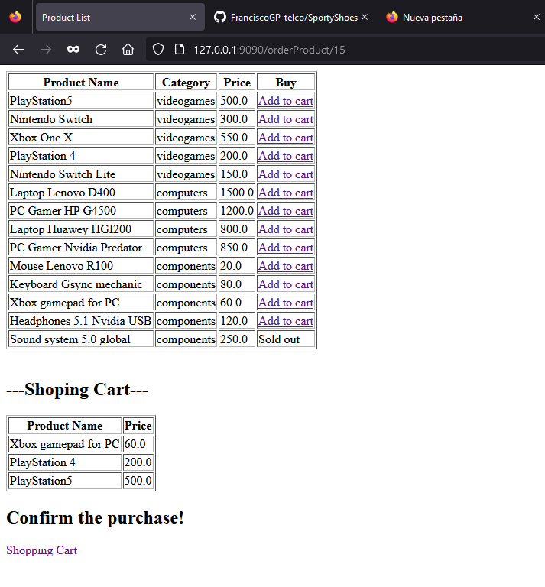

# Confirmation of the purchase:

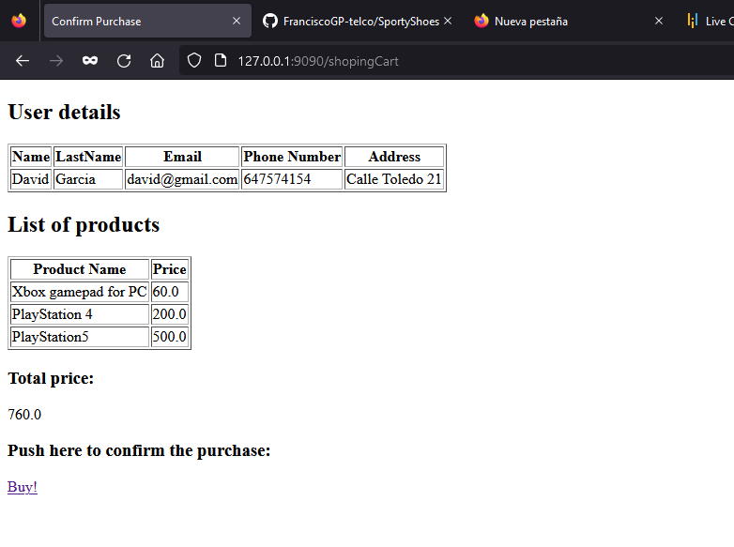

# Purchase confirmed:

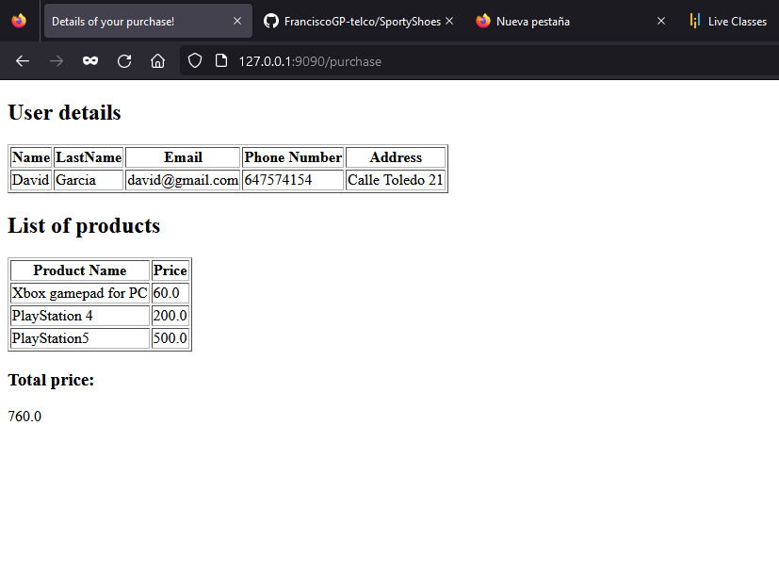

# Checking the purchase in the DB:

# Login with the admin users:

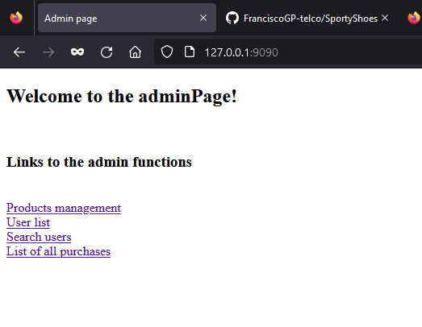

# Product management (editing category)

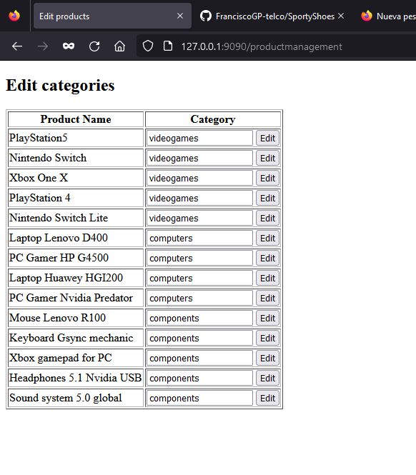

# After edit:

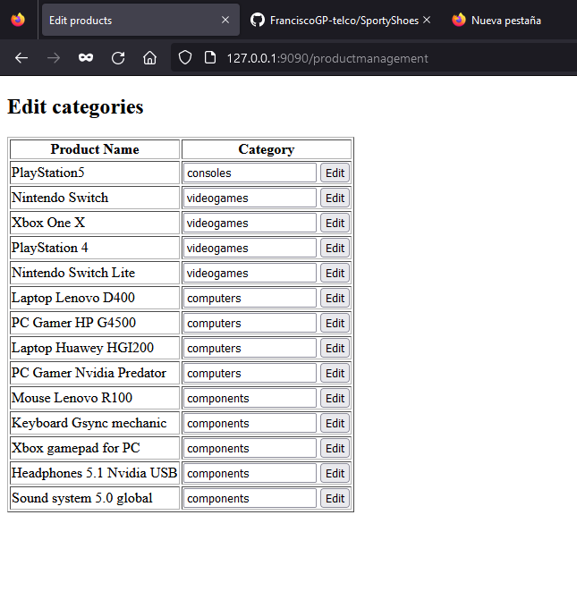

# Checking the DB:

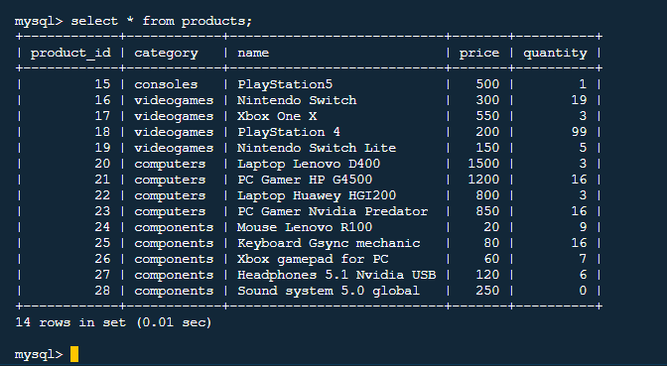

# UserList:

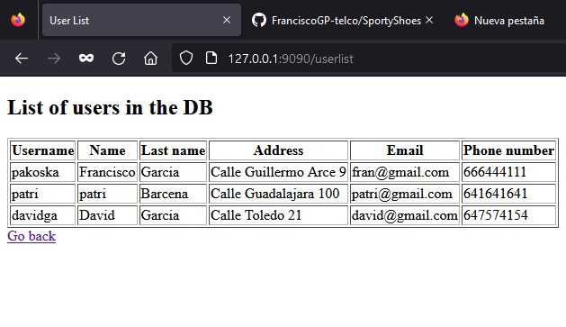

# Search for users:

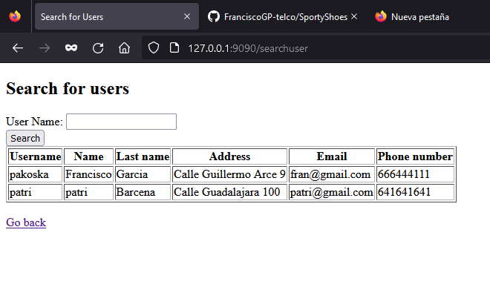

# List of purchases:

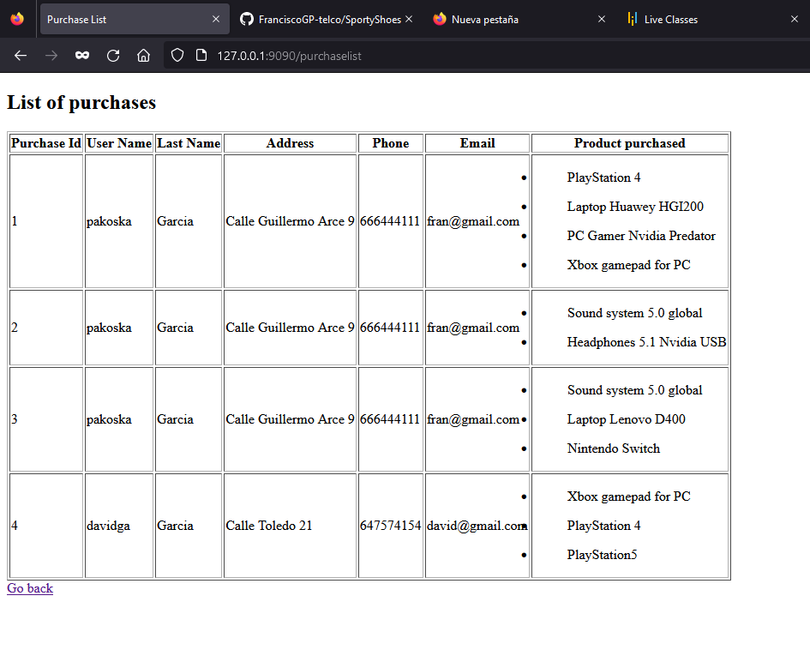

More info about the project and the full source code can be found in the GitHub project:

<https://github.com/FranciscoGP-telco/SportyShoes>